**HINDUSTHAN COLLEGE OF ENGINEERING AND TECHNOLOGY**



**(AUTONOMOUS)**

|  |  |
| --- | --- |
| Date | 30 September 2022 |
| Team ID | PNT2022TMID10014 |
| Project Name | IOT Gas Leakage Monitoring and Alerting System. |

**Solution Architecture:**

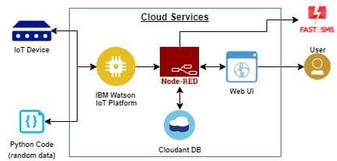

Email Notification